Recalls Report Specification

Peninsula Health

Version: 1.1

Status: Draft

Issue date: 09/06/2016

Table of contents

1 Scope 1

2 Report Details 2

2.1 Report Name 2

2.2 T Case No. 2

2.3 Report Description 2

2.4 Frequency and Audience 2

2.5 Report Menu Category 2

2.6 Prerequisite Attribute SetUp 2

2.6.1 Shift Count Type 3

2.7 Input Parameters 3

2.8 Report Header 6

2.9 Group Headers 7

2.10 Report Body 7

2.11 Report Totals 9

2.12 Sort Order 9

2.13 Group 9

2.14 Report Orientation & Size 9

2.15 Report Formatting 9

2.16 Security Profile 10

2.17 Standard Report Reference 10

2.18 Sample Format 10

2.18.1 Sample Data 10

2.18.2 Sample Format of Report with sample data 10

3 Sign-Off 12

4 Change control history 13

# Scope

The purpose of this document is to describe the specification for a Recalls Report required by Peninsula Health.

# Report Details

## Report Name

The name of the report is PEN: Recalls

## Report Description

The intention of this report is to provide an overview of detailed on-call and recall shifts information; Along with an additional column to show comments documented in the free-text field.

## Frequency and Audience

This report is intended to be used by rostering manager who needs an understanding of on-call/recall staffing.

This report will be scheduled to run but it will also be run manually.

## Report Menu Category

This Report is to be made available in the Actual Reports Wizard

## Input Parameters

| **Argument** | **Description** | **Comment** |
| --- | --- | --- |
| From Date | From date of required period | This report will only run for the selected period. |
| To Date | To date of required period | This report will only run for the selected period. |
| Area | All areas that the operator has read access to for this report | This report will only run for the selected area. |

## Report Header

|  |  |
| --- | --- |
| **Header** | **Description** |
| Report Header | PEN: Recalls |
| From and To dates | Display the selected from and to dates |
| Area | Display the selected area description |

## Report Footer

|  |  |
| --- | --- |
| **Footer** | **Description** |
| Page Number | Display the current page number |
| Date and Time Created | Display the time and date the report was ran |

## Report Body

**Main Report**

**The main report data will be drawn from Actual Data in Step 3 Actual**

|  |  |
| --- | --- |
| **Column** | **Description** |
| On Call Date | The start date of on call shift in the format of “DD/MM/YYYY”, e.g. “02/05/2016” |
| Oncall Shift | The on call shift start and end time in the format of “HH:MM to HH:MM”, e.g. “17:00 to 07:30” |
| Emp No. | Employee Number |
| Employee Name | Employee’s Surname, First Name  e.g. Smith, John |
| Recall Date | The start date of recall shift in the format of “DD/MM/YYYY”, e.g. “02/05/2016” |
| Start | The start time of recall shift in the format of “HH:MM”, e.g. “01:00” |
| Finish | The end tart time of recall shift in the format of “HH:MM”, e.g. “03:15” |
| Hours | Duration of the recall shift in hours, e.g. 2.25 |
| Type | The type of recall, e.g. “Recall to work”, “Telephone Recall”. |
| Comments | The free-text documented comment in *Comment* field of the recall shift. Up to 255 characters and does wrapping into multiple lines. |

## Sort Order

This report is sorted by area description, then on-call start date, then on-call start time, then recall start date, then recall start time, then employee number.

## Report Orientation & Size

This report is to be produced in *A4 Landscape*

## Report Formatting

As per the example in 2.14

## Security Profile

*{Secure same as a standard RosterOn report or nominate standard profiles}*

## Standard Report Reference

Recalls Report

## Sample Format

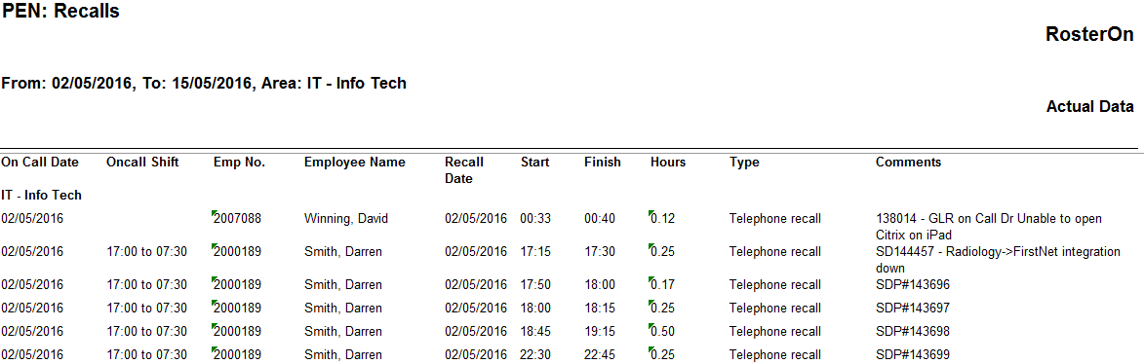

# Sign-Off

Please complete the following table for signoff for the above design:

|  |  |
| --- | --- |
| **Print Name:** |  |
| **Authorisation Signature:** |  |
| **Organisation:** |  |
| **Print Name:** |  |
| **Authorisation Signature:** |  |
| **Organisation:** |  |

# Change control history

|  |  |  |  |  |  |
| --- | --- | --- | --- | --- | --- |
| Issue No | Issue Date | Description | Document authorisation | | |
| Author | Reviewer(s) | Approver |
| 1.0 | 24/05/2016 | First Draft | Ben Shi | Gareth Shaw |  |
| 1.1 | 09/06/2016 | Draft | Ben Shi |  |  |
|  |  |  |  |  |  |
|  |  |  |  |  |  |

|  |  |  |  |
| --- | --- | --- | --- |
| Allocate Software plc  Corporate Head Office  1 Church Road,  Richmond,  TW9 2QE  Tel. +44 (0)20 7355 5555  Fax +44 (0)20 7355 5588 | UK Regional Office  Compass House  The Point  Coach Road  Shireoaks  Worksop  NOTTS  S81 8BW  Tel. +44 (01909) 506276  Fax +44 (01909) 478165 | UK Regional Office  Unit 5 Kings Meadow  Ferry Hinksey Road  Oxford  OX2 0DP  Tel: + 44 3300 881 757  Fax: +44 8715 289 031 | UK Regional Office  The Innovation Centre 2  Keele University Science Park  2nd Floor IC3,  Keele  Staffordshire  ST5 5NP  Tel. +44 (0) 1782 667001  Fax +44 (0) 1782 667009 |
| Time Care AB  Swedish Head Office  Franzéngatan 3 3tr  112 51 Stockholm    Tel: +46 8 5055 1800  Fax: +46 8 5055 1899 | Time Care AB  Swedish Regional Office  Kronhusgatan 11  411 05 Göteborg  Tel: +46 (0) 31 724 28 80  Fax: +46 (0) 31 724 27 01 | Allocate Software PTY Ltd  Australian Head Office  Suite 2, Level 13,  99 Mount St  North Sydney NSW 2060 Australia  Tel. 1300 767 837 or +61 (0) 3 9534 4477 | Allocate Software PTY Ltd  Australian regional Office  RosterOn Pty Ltd Level 6, 636 St Kilda Rd  Melbourne 3004  Tel: local 1300 767837 international +61 3 95344477  Fax: +61 3 9510 8681 |

enquiries@allocatesoftware.com

[www.allocatesoftware.com](http://www.manpowersoftware.com)

© Copyright 2015 Allocate Software plc and its subsidiaries

All rights reserved. All identified product names of other companies may be trademarks or registered trademarks of their respective owners. The materials presented here are summary in nature, subject to change, and intended for general information only.

05/09